Data analytics on COVID-19 dataset Using HiveQL

Problem Statement :
To analyse the Covid-19 dataset collected from Kaggle using the Hive queries and note down the interesting facts about the COVID-19 in different Countries.

Dataset Description:

* covid_19_data.csv
*Semi- structured data
*21220 Rows
* Eight Columns
#SNO – serial number - int
#ObservationDate – mm/dd/yyyy
#Province / State - String
#Country / Region - String
#Last Update - Last update date time in UTC
#Confirmed - Cumulative number of confirmed cases – Float
#Deaths - Cumulative number of deaths cases - Float
#Recovered - Cumulative number of recovered cases - Float

#create database

hive> create database analyze WITH DBPROPERTIES('creator'='JP','date'='2020/05/13');
OK
Time taken: 0.364 seconds

#creating table

hive> create table covid_19(SNo int,ObservationDate string,Province_or_State String,Country_or_Region String,Last_Update string,Confirmed int,Deaths int,Recovered int) row format delimited fields terminated by ',';
OK
Time taken: 0.973 seconds

#Loading data

hive> load data local inpath '/home/jp/covid_19_data.csv' into table covid_19;
Copying data from file:/home/jp/covid_19_data.csv
Copying file: file:/home/jp/covid_19_data.csv
Loading data to table default.covid_19
Table default.covid_19 stats: [numFiles=1, numRows=0, totalSize=1386870, rawDataSize=0]
OK
Time taken: 1.465 seconds
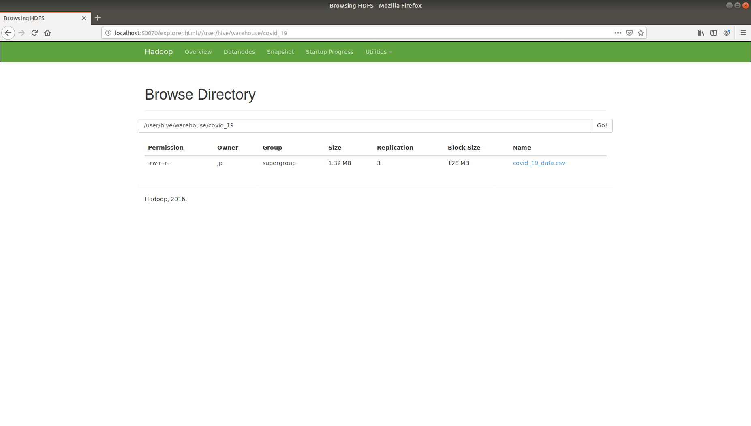
Data Analysis Queries

1. provinces/state with deaths > 1000

hive> select Province_or_State from covid_19 where Deaths>1000;
Total jobs = 1
Launching Job 1 out of 1
Number of reduce tasks is set to 0 since there's no reduce operator
Execution log at: /tmp/jp/jp_20200514155757_a3e9bc32-5a9d-4d6b-a759-e27177e13bc6.log
Job running in-process (local Hadoop)
Hadoop job information for null: number of mappers: 0; number of reducers: 0
2020-05-14 15:58:01,421 null map = 100%, reduce = 0%
Ended Job = job_local262375051_0001
Execution completed successfully
MapredLocal task succeeded
OK

2. All the records corresponding to the country India
hive> select * from covid_19 where Country_or_Region='India';

3.select countries whose death rate is greater than recovery rate
hive> select Province_or_State,Country_or_Region,Deaths,Recovered from covid_19 where Deaths>Recovered order by Deaths;

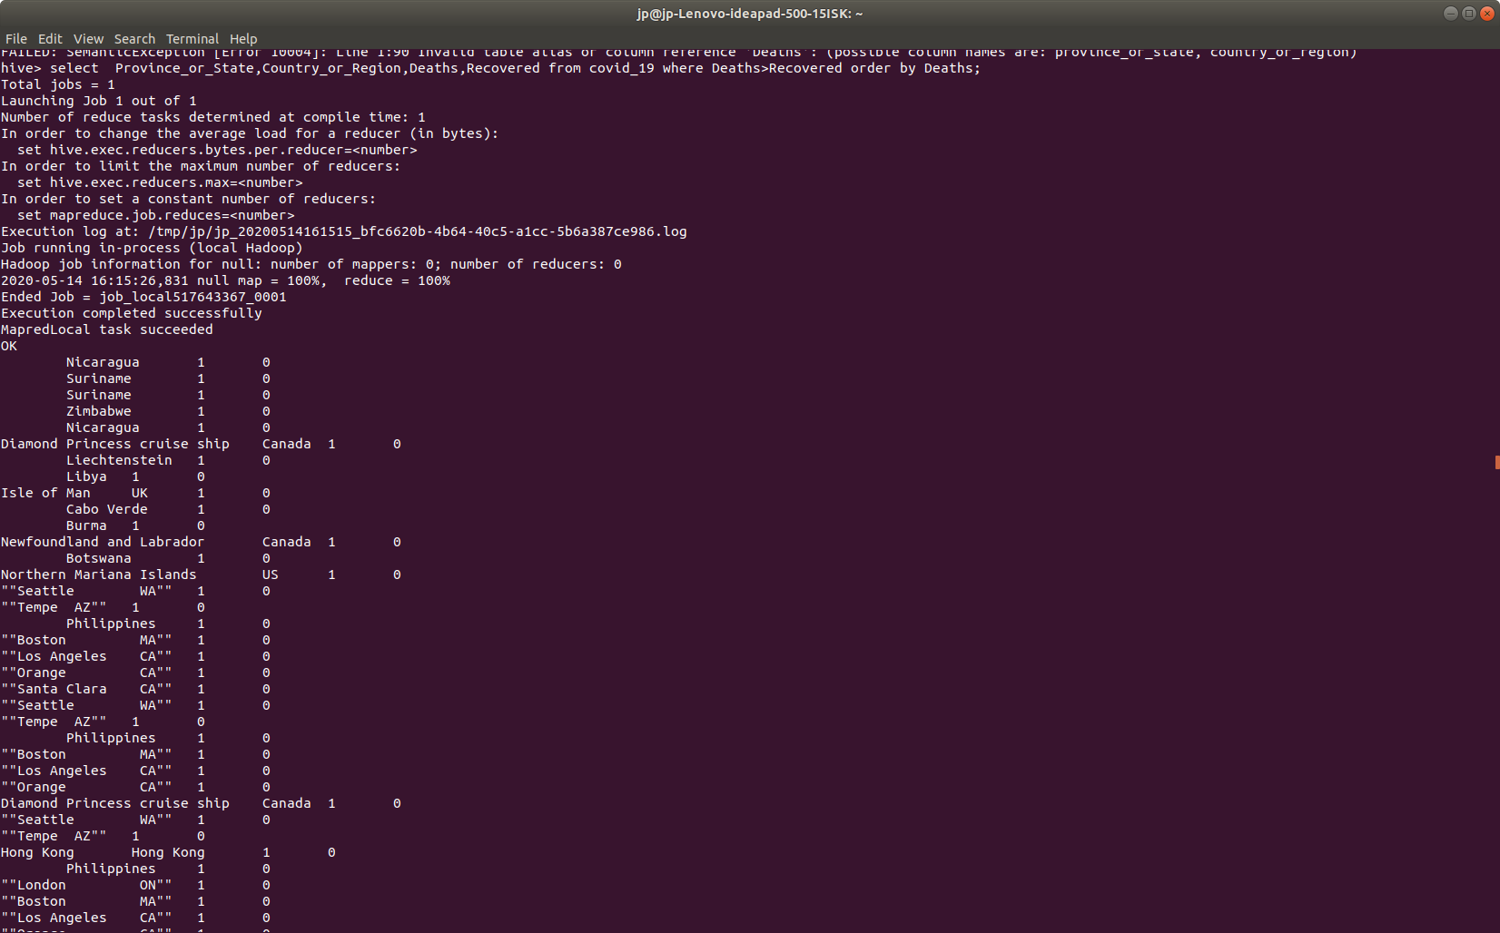
4.Number of records available for in each country
hive> select Country_or_Region,count(*) from covid_19 group by Country_or_Region;


5. Number of Confirmed cases in Each Country
hive> select Country_or_Region,Sum(Confirmed) from covid_19 group by Country_or_Region;



6. Total Number of deaths and recovered cases in each Region
select Country_or_Region,Sum(Deaths),sum(Recovered) from covid_19 group by Country_or_Region;


7.Number of states affected in each country
hive> select Country_or_Region,count(Province_or_State) from covid_19 group by Country_or_Region;

...

8. Number of new cases, deaths, recovered on each recorded date
hive> select ObservationDate,sum(Confirmed),sum(Deaths),sum(Recovered) from covid_19 group by ObservationDate;
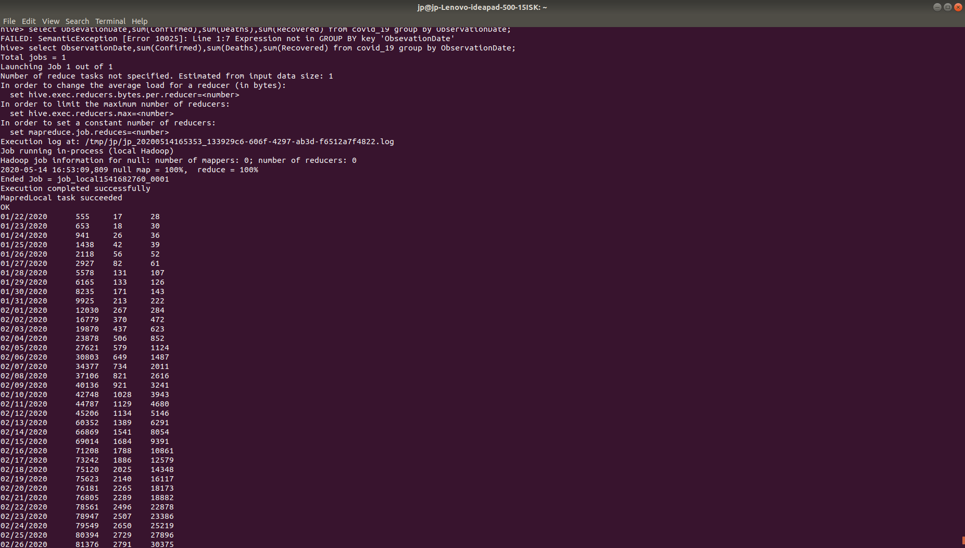
..
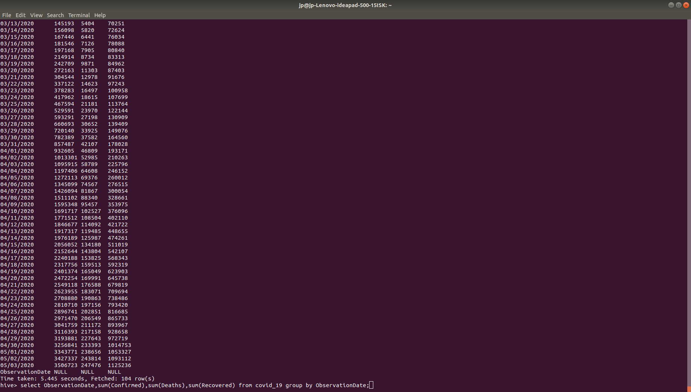
9. Date in which Maximum deaths happened
hive> select Country_or_Region,max(Deaths) from covid_19 group by Country_or_Region;

..

10.what is the Maximum Deaths rate in this dataset?

hive> select max(Deaths) from covid_19;

11. Country and Date in which maximum Deaths reported

hive> select Country_or_Region,ObservationDate from covid_19 where Deaths=28884;
Total jobs = 1
Launching Job 1 out of 1
Number of reduce tasks is set to 0 since there's no reduce operator
Execution log at: /tmp/jp/jp_20200514171212_7d2f04ac-1e70-4467-9a56-9df1d6899e81.log
Job running in-process (local Hadoop)
Hadoop job information for null: number of mappers: 0; number of reducers: 0
2020-05-14 17:12:16,545 null map = 100%, reduce = 0%
Ended Job = job_local424081442_0001
Execution completed successfully
MapredLocal task succeeded
OK
Italy 05/03/2020
Time taken: 5.133 seconds, Fetched: 1 row(s)

12. what is the maximum recovery rate and Disease confirmed in this dtaset?

select max(Confirmed),max(Recovered) from covid_19;
Total jobs = 1
Launching Job 1 out of 1
Number of reduce tasks determined at compile time: 1
In order to change the average load for a reducer (in bytes):
set hive.exec.reducers.bytes.per.reducer=<number>
In order to limit the maximum number of reducers:
set hive.exec.reducers.max=<number>
In order to set a constant number of reducers:
set mapreduce.job.reduces=<number>
Execution log at: /tmp/jp/jp_20200514172424_0ca1931d-fc75-4f2e-94a7-f8c7a30bce47.log
Job running in-process (local Hadoop)
Hadoop job information for null: number of mappers: 0; number of reducers: 0
2020-05-14 17:24:35,456 null map = 100%, reduce = 100%
Ended Job = job_local1002607731_0001
Execution completed successfully
MapredLocal task succeeded
OK
316415 180152
Time taken: 5.215 seconds, Fetched: 1 row(s)
hive>

13. Country and Date in which maximum cases were confirmed

hive> select Country_or_Region,ObservationDate from covid_19 where Confirmed=316415;
Total jobs = 1
Launching Job 1 out of 1
Number of reduce tasks is set to 0 since there's no reduce operator
Execution log at: /tmp/jp/jp_20200514172727_97b141e2-e949-432a-bb63-3d972240e61b.log
Job running in-process (local Hadoop)
Hadoop job information for null: number of mappers: 0; number of reducers: 0
2020-05-14 17:27:14,227 null map = 100%, reduce = 0%
Ended Job = job_local1000888741_0001
Execution completed successfully
MapredLocal task succeeded
OK
US 05/03/2020
Time taken: 5.151 seconds, Fetched: 1 row(s)
hive>

14. Country , Date in which maximum patients were recovered

hive> select Country_or_Region,ObservationDate from covid_19 where Recovered=180152;
Total jobs = 1
Launching Job 1 out of 1
Number of reduce tasks is set to 0 since there's no reduce operator
Execution log at: /tmp/jp/jp_20200514172929_e7fe2665-367e-4607-963f-e32d4984e593.log
Job running in-process (local Hadoop)
Hadoop job information for null: number of mappers: 0; number of reducers: 0
2020-05-14 17:30:01,424 null map = 100%, reduce = 0%
Ended Job = job_local1314939815_0001
Execution completed successfully
MapredLocal task succeeded
OK
US 05/03/2020
Time taken: 5.162 seconds, Fetched: 1 row(s)

15. Provinces/State and Country/Region where no death were reported.

hive> select Province_or_State,Country_or_Region from covid_19 where deaths=0;
Total jobs = 1
Launching Job 1 out of 1
Number of reduce tasks is set to 0 since there's no reduce operator
Execution log at: /tmp/jp/jp_20200514183535_21571cfa-fd8d-4b64-9a25-89727e34f1de.log
Job running in-process (local Hadoop)
Hadoop job information for null: number of mappers: 0; number of reducers: 0
2020-05-14 18:35:04,839 null map = 100%, reduce = 0%
Ended Job = job_local204252203_0001
Execution completed successfully
MapredLocal task succeeded
OK
Anhui Mainland China
Beijing Mainland China
Chongqing Mainland China
Fujian Mainland China
Gansu Mainland China
Guangdong Mainland China
Guangxi Mainland China
Guizhou Mainland China
Hainan Mainland China
Hebei Mainland China
Heilongjiang Mainland China
Henan Mainland China
Hong Kong Hong Kong
Hunan Mainland China
Inner Mongolia Mainland China
Jiangsu Mainland China
Jiangxi Mainland China
...
Macau Macau
New Brunswick Canada
New Caledonia France
Ningxia Mainland China
Northern Territory Australia
Northwest Territories Canada
Prince Edward Island Canada
Qinghai Mainland China
Recovered Canada
Recovered US
Reunion France
Saint Barthelemy France
Saint Pierre and Miquelon France
Shanxi Mainland China
Tibet Mainland China
Yukon Canada
Time taken: 5.222 seconds, Fetched: 7680 row(s)

16. Provinces/ state in china where Death rate is higher than recovery rate

hive> select Province_or_State from (select Province_or_State,Country_or_Region from covid_19 where Deaths<Recovered and Country_or_Region='Mainland China') a group by a.Province_or_State;
Total jobs = 1
Launching Job 1 out of 1
Number of reduce tasks not specified. Estimated from input data size: 1
In order to change the average load for a reducer (in bytes):
set hive.exec.reducers.bytes.per.reducer=<number>
In order to limit the maximum number of reducers:
set hive.exec.reducers.max=<number>
In order to set a constant number of reducers:
set mapreduce.job.reduces=<number>
Execution log at: /tmp/jp/jp_20200514184949_7a7b8c90-ddf4-400a-84cf-cde451f38c1d.log
Job running in-process (local Hadoop)
Hadoop job information for null: number of mappers: 0; number of reducers: 0
2020-05-14 18:49:34,747 null map = 100%, reduce = 100%
Ended Job = job_local954708485_0001
Execution completed successfully
MapredLocal task succeeded
OK
Anhui
Beijing
Chongqing
Fujian
Gansu
Guangdong
Guangxi
Guizhou
Hainan
Hebei
Heilongjiang
Henan
Hubei
Hunan
Inner Mongolia
Jiangsu
Jiangxi
Jilin
Liaoning
Ningxia
Qinghai
Shaanxi
Shandong
Shanghai
Shanxi
Sichuan
Tianjin
Tibet
Xinjiang
Yunnan
Zhejiang
Time taken: 5.163 seconds, Fetched: 31 row(s)

17. Countries where Death rate is 10 times greater tha the Recovery rate

hive> select Country_or_Region from (select * from covid_19 where Deaths=(10* Recovered)) a Group by a.Country_or_Region;
Total jobs = 1
Launching Job 1 out of 1
Number of reduce tasks not specified. Estimated from input data size: 1
In order to change the average load for a reducer (in bytes):
set hive.exec.reducers.bytes.per.reducer=<number>
In order to limit the maximum number of reducers:
set hive.exec.reducers.max=<number>
In order to set a constant number of reducers:
set mapreduce.job.reduces=<number>
Execution log at: /tmp/jp/jp_20200514210707_b927bfde-7e96-42ea-9681-00967059b964.log
Job running in-process (local Hadoop)
Hadoop job information for null: number of mappers: 0; number of reducers: 0
2020-05-14 21:07:30,505 null map = 100%, reduce = 100%
Ended Job = job_local975267134_0001
Execution completed successfully
MapredLocal task succeeded
OK
Azerbaijan
CA (From Diamond Princess)""
NE (From Diamond Princess)""
TX (From Diamond Princess)""
TX""
Afghanistan
Albania
Algeria
Andorra
Angola
Antigua and Barbuda
Argentina
Armenia
Aruba
Australia
Austria
Azerbaijan
Bahamas
Bahrain
Bangladesh
Barbados
Belarus
Belgium
Belize
...
Vatican City
Venezuela
Vietnam
Western Sahara
Yemen
Zambia
Zimbabwe
occupied Palestinian territory
Time taken: 5.331 seconds, Fetched: 218 row(s)
hive>

18. What are the top 5 Provinces and Countries with highest Death rate?

hive> select Province_or_State,Country_or_region,Deaths from covid_19 sort by Deaths DESC limit 5;
Total jobs = 2
Launching Job 1 out of 2
Number of reduce tasks not specified. Estimated from input data size: 1
In order to change the average load for a reducer (in bytes):
set hive.exec.reducers.bytes.per.reducer=<number>
In order to limit the maximum number of reducers:
set hive.exec.reducers.max=<number>
In order to set a constant number of reducers:
set mapreduce.job.reduces=<number>
Execution log at: /tmp/jp/jp_20200514211717_fbc5f1c8-08ab-4410-b4e4-83266504df33.log
Job running in-process (local Hadoop)
Hadoop job information for null: number of mappers: 0; number of reducers: 0
2020-05-14 21:17:47,209 null map = 100%, reduce = 100%
Ended Job = job_local153603611_0001
Execution completed successfully
MapredLocal task succeeded
Launching Job 2 out of 2
Number of reduce tasks determined at compile time: 1
In order to change the average load for a reducer (in bytes):
set hive.exec.reducers.bytes.per.reducer=<number>
In order to limit the maximum number of reducers:
set hive.exec.reducers.max=<number>
In order to set a constant number of reducers:
set mapreduce.job.reduces=<number>
Execution log at: /tmp/jp/jp_20200514211717_fbc5f1c8-08ab-4410-b4e4-83266504df33.log
Job running in-process (local Hadoop)
Hadoop job information for null: number of mappers: 0; number of reducers: 0
2020-05-14 21:17:52,866 null map = 100%, reduce = 100%
Ended Job = job_local826202177_0001
Execution completed successfully
MapredLocal task succeeded
OK
Italy 28884
Italy 28710
UK 28446
Italy 28236
UK 28131
Time taken: 11.404 seconds, Fetched: 5 row(s)

19. Provinces which are reported highest number of confirmed cases (Top 5)

hive> select ObservationDate,Province_or_State,Country_or_region,Confirmed from covid_19 sort by Confirmed DESC limit 5;
Total jobs = 2
Launching Job 1 out of 2
Number of reduce tasks not specified. Estimated from input data size: 1
In order to change the average load for a reducer (in bytes):
set hive.exec.reducers.bytes.per.reducer=<number>
In order to limit the maximum number of reducers:
set hive.exec.reducers.max=<number>
In order to set a constant number of reducers:
set mapreduce.job.reduces=<number>
Execution log at: /tmp/jp/jp_20200514212929_266c272a-bc30-4f5f-b463-f87aaf1e34c0.log
Job running in-process (local Hadoop)
Hadoop job information for null: number of mappers: 0; number of reducers: 0
2020-05-14 21:29:24,337 null map = 100%, reduce = 100%
Ended Job = job_local1234640406_0001
Execution completed successfully
MapredLocal task succeeded
Launching Job 2 out of 2
Number of reduce tasks determined at compile time: 1
In order to change the average load for a reducer (in bytes):
set hive.exec.reducers.bytes.per.reducer=<number>
In order to limit the maximum number of reducers:
set hive.exec.reducers.max=<number>
In order to set a constant number of reducers:
set mapreduce.job.reduces=<number>
Execution log at: /tmp/jp/jp_20200514212929_266c272a-bc30-4f5f-b463-f87aaf1e34c0.log
Job running in-process (local Hadoop)
Hadoop job information for null: number of mappers: 0; number of reducers: 0
2020-05-14 21:29:29,213 null map = 100%, reduce = 100%
Ended Job = job_local1803161357_0001
Execution completed successfully
MapredLocal task succeeded
OK
05/03/2020 New York US 316415
05/02/2020 New York US 312977
05/01/2020 New York US 308314
04/30/2020 New York US 304372
04/29/2020 New York US 299691
Time taken: 9.699 seconds, Fetched: 5 row(s)

20.Number of days in which the countries reported less than 10 covid cases.

hive> select Country_or_Region,count(ObservationDate) from (select * from covid_19 where Confirmed<10)a group by a.Country_or_Region limit 10;
Total jobs = 1
Launching Job 1 out of 1
Number of reduce tasks not specified. Estimated from input data size: 1
In order to change the average load for a reducer (in bytes):
set hive.exec.reducers.bytes.per.reducer=<number>
In order to limit the maximum number of reducers:
set hive.exec.reducers.max=<number>
In order to set a constant number of reducers:
set mapreduce.job.reduces=<number>
Execution log at: /tmp/jp/jp_20200514214242_a1380fbd-95b8-4780-8e8a-42bc9f3add6f.log
Job running in-process (local Hadoop)
Hadoop job information for null: number of mappers: 0; number of reducers: 0
2020-05-14 21:42:53,168 null map = 100%, reduce = 100%
Ended Job = job_local762974326_0001
Execution completed successfully
MapredLocal task succeeded
OK
Azerbaijan 1
Afghanistan 19
Albania 1
Algeria 8
Andorra 15
Angola 15
Antigua and Barbuda 21
Argentina 5
Armenia 13
Aruba 7
Time taken: 4.978 seconds, Fetched: 10 row(s)

INFERENCES

* it is clear that the Italy was badly affected by COVID 19 in this period ( Q11)
[ 28884 deaths as of 05/03/2020]

* Most of the European countries were in a helpless situation because of the Death Rate>=10* recovery rate.[Q17]

It also indicates that the social distancing was not efficiently happened in these Regions.
* In May, COVID spreading started in US.Large number of cases where reported in this month.(Q19).

* In this period, Large number of deaths Reported in ITALY ,UK.
It was the 3rd stage of COVID_19 pandemic in these countries.(Q18)

* INDIA is no where in the TOP 5 list of countries with highest Deaths, Confirmed cases.
IN this period LOCK DOWN in INDIA was very helpful to achieve social diatancing and there by reduce the spread.

SUMMARY

Here we have considered the “ Nvel corona virus 2019 ”dataset which contains the records
of covid affected cases among the countries in the interval 01/01/2020 to 03/05/2020.

From the above inferences it is loud and clear that the countries which are not taken sufficient precautions and Social distancing will lead to social spread and then the health care systems becomes helpless due to uncontrolled deaths and low recovery rates.

INDIA is the second largest populated country and due to the high population density the possibilities for the social spread is high. But from the above analysis it is clear that the population and quality of health care system is not an import factor for COVID19 Pandemic. Only the right decision at the right time to take precautions matters.

